

All rights reserved © Company PAVONECONCEPTS**® Guaranty confidentiality**

**Phon**[**www.PavoneConcepts.com**](http://www.PavoneConcepts.com)

**e: +32 498162896 / +32 470288831**

**Mail :** [**info@pavoneconcepts.com**](mailto:info@pavoneconcepts.com)

**VAT/BTW : BE0665 492 353**

**ING BANK : BE25 3632 4519 1182**

**Christophe Pavone™.** 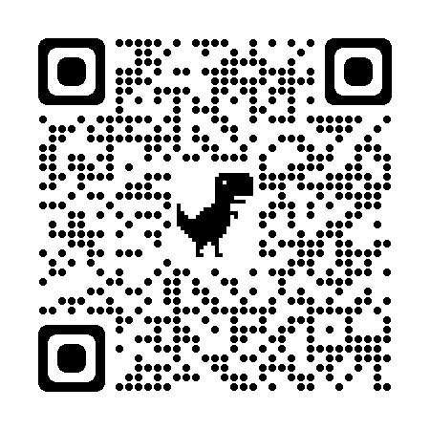

**CLIENT conract info : ……………………………………………………………………………………………………………………………….**

**PavoneConcepts: Sketch N°............ File................**